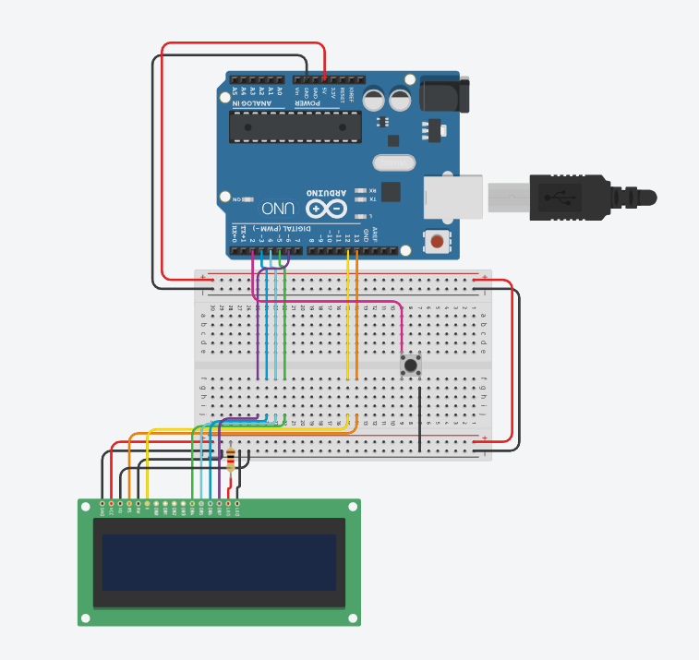
#include <LiquidCrystal.h>
#include <avr/interrupt.h>

LiquidCrystal lcd(13, 12, 5, 4, 3, 6);

const int buttonPin = 2;

volatile int tenths = 0;
volatile int seconds = 0;
volatile int minutes = 0;

enum TimerState { STOPPED, RUNNING };
volatile TimerState timerState = STOPPED;

unsigned long buttonPressStart = 0;
bool buttonHeld = false;

void setup() {
Serial.begin(9600);
lcd.begin(16, 2);
lcd.setCursor(0, 0);
lcd.print("Stopwatch Timer");
lcd.setCursor(0, 1);
lcd.print("00:00:0");

pinMode(buttonPin, INPUT_PULLUP);
attachInterrupt(digitalPinToInterrupt(buttonPin), handleButtonPress, FALLING);

cli();
TCCR1A = 0;
TCCR1B = 0;
TCNT1 = 0;
OCR1A = 1562.5;
TCCR1B |= (1 << WGM12);
TCCR1B |= (1 << CS12) | (1 << CS10);
TIMSK1 |= (1 << OCIE1A);
sei();
}

ISR(TIMER1_COMPA_vect) {
if (timerState == RUNNING) {
tenths++;
if (tenths >= 10) {
tenths = 0;
seconds++;
if (seconds >= 60) {
seconds = 0;
minutes++;
}
}
updateDisplay();
}
}

void updateDisplay() {
lcd.setCursor(0, 1);
lcd.print((minutes < 10 ? "0" : "") + String(minutes) + ":");
lcd.print((seconds < 10 ? "0" : "") + String(seconds) + ":");
lcd.print(String(tenths));
}

void handleButtonPress() {
buttonPressStart = millis();
buttonHeld = true;
}

void checkButtonHold() {
if (buttonHeld && digitalRead(buttonPin) == LOW) {
if (millis() - buttonPressStart > 3000) {
timerState = STOPPED;
tenths = 0;
seconds = 0;
minutes = 0;
updateDisplay();
buttonHeld = false;
}
} else if (buttonHeld && digitalRead(buttonPin) == HIGH) {
buttonHeld = false;
if (timerState == STOPPED) {
timerState = RUNNING;
} else {
timerState = STOPPED;
}
}
}

void loop() {
checkButtonHold();
}

